**Summan Gul**

**SP20-BCS-048**

**MAD Lab Task**

**Question: Design Signup page in react native.**

**Expo App Output:**

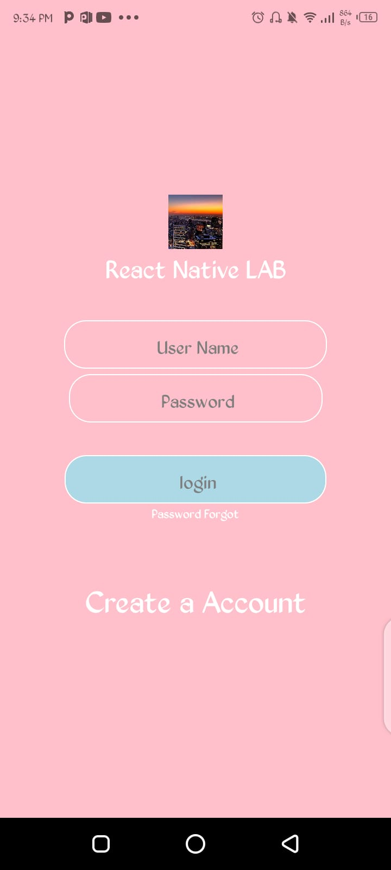

**Web Output:**

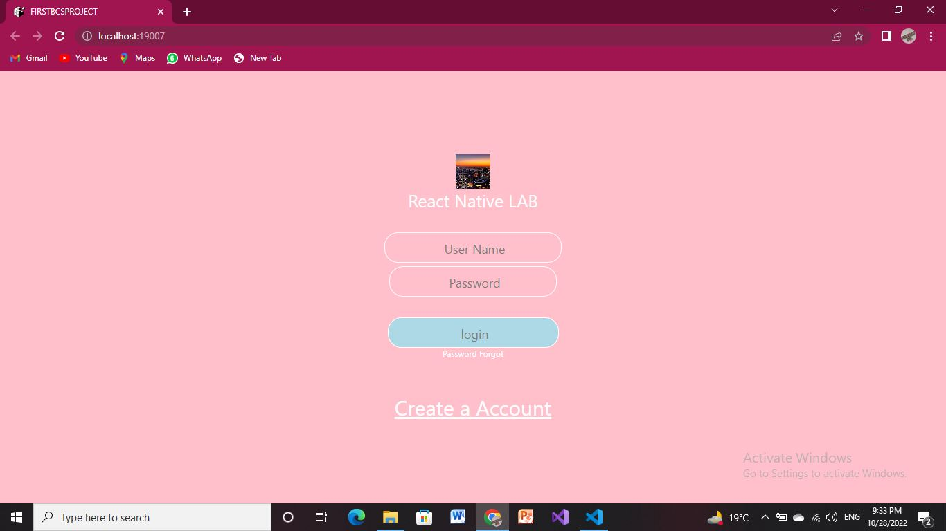

**Code:**

import React from "react";

import {StyleSheet , View , Image, Text } from "react-native";

export default function Signup(){

return(

<View style = {styles.container} >

<View style = {styles.box1}>

<Image

style = {styles.Imagestyle}

source = {require("./assets/Screen.jpg")}></Image>

</View>

<View >

<Text style = {{fontSize:25 , color:"white" , fontweight :

"bold"}}>React Native LAB</Text>

</View>

<View style={styles.inputstyle}>

<Text style = {styles.label}> User Name</Text>

</View>

<View style={styles.inputstyle2}>

<Text style = {styles.label }> Password</Text>

</View>

<View style={styles.inputstyle3}>

<Text style = {styles.label} > login</Text>

</View>

<View >

<Text style = {{ fontSize:12 , color:"white" , fontweight : "bold"}}>

Password Forgot

</Text>

</View>

<View style = {styles.style1}>

<Text style = {{ fontSize:30 , color:"white" , fontweight : "bold"}}>

Create a Account

</Text>

</View>

</View>

);

}

const styles = StyleSheet.create({

container:{

backgroundColor : "Lightpink",

flex : 1,

flexDirection:"column",

justifyContent : "center",

alignItems : "center",

textDecorationColor:"white",

},

box1 : {

width : 50,

height : 50,

},

Imagestyle:{

width: 50,

height : 50

},

label:{

fontSize:18,

color:"white",

marginTop:10,

marginBottom:5,

lineHeight:25,

},

inputstyle:{

marginTop:30,

borderWidth:1,

borderColor : "white",

paddingHorizontal:80,

paddingVertical:1,

borderRadius:2,

borderBottomLeftRadius : 20,

borderTopLeftRadius:20,

borderBottomRightRadius:20,

borderTopRightRadius:20,

},

inputstyle2:{

marginTop:5,

borderWidth:1,

borderColor : "white",

paddingHorizontal:80,

paddingVertical:1,

borderRadius:1,

borderBottomLeftRadius : 20,

borderTopLeftRadius:20,

borderBottomRightRadius:20,

borderTopRightRadius:20

},

inputstyle3:{

backgroundColor:"Black",

marginTop:30,

borderWidth:1,

borderColor : "white",

paddingHorizontal:100,

paddingVertical:1,

borderRadius:1,

borderBottomLeftRadius : 20,

borderTopLeftRadius:20,

borderBottomRightRadius:20,

borderTopRightRadius:20

},

style1:{

textDecorationLine : "underline",

textDecorationColor:"white",

marginTop:50

}

})